CTR PREDICTION
What Is CTR?
CTR = Click Through Rate
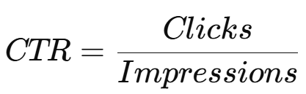

Why Important?
Ad systems monetize clicks.
CTR prediction:
- predicts probability of click

ML Formulation
Binary classification.
P(click∣user,item,context)

Features
- user history
- session
- device
- embeddings
- ad metadata
Models
- Logistic regression
- XGBoost
- DLRM
- Wide & Deep
- Transformers

Hands-On POC
Predict ad clicks using:
- Criteo CTR dataset

Trade-Offs
Simple Models | Deep Models
Interpretable | Better accuracy
Fast | Expensive
Stable | Harder to debug
Principal-Level Topics
- Calibration
- Delayed feedback
- Feedback loops
- Sparse positives

